* + **Topics**
  + **Partitions**
  + **Offsets**
  + **Producers**
  + **Consumers**
  + **Consumer Groups**
  + **Message Keys**
  + **Producer acknowledgements**
  + **Zookeeper**

Machine generated alternative text:
Source System
Kafka Cluster
+ topics
+ partitions :
+ replications ;
+ partition leader & in-sync-replicas (ISR)
+ offsets topic
f I
+ round robin
+ key based ordering
+ acks strategy
+ consumer groups !
+ at least once !
+ at most once !
Broker 101
---,
Producers
---.
Broker 102
I..
---.
Consumers
Broker 109
---.
Target Systems

**Topic:**

**a particular stream of data**

**Partition and Offset :**

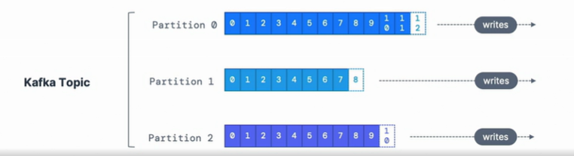

**Producers:**

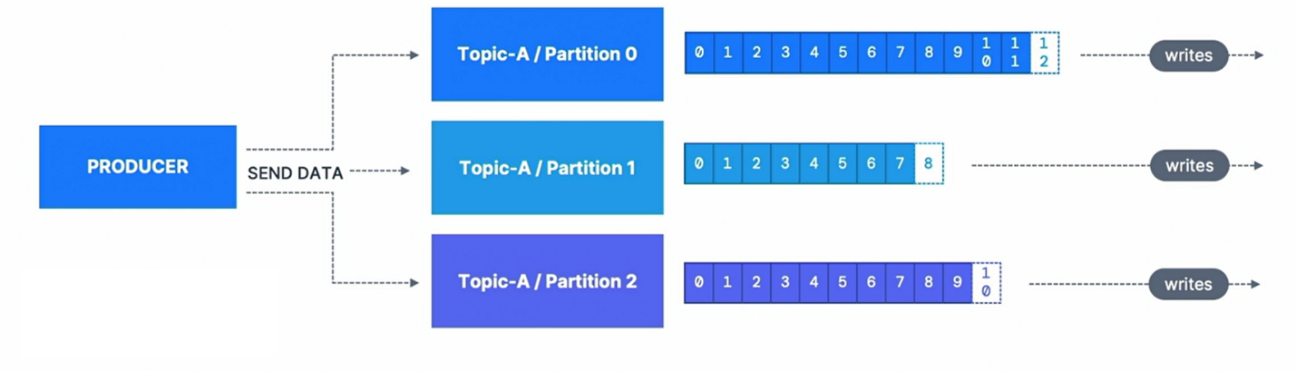

**MessageKeys:**

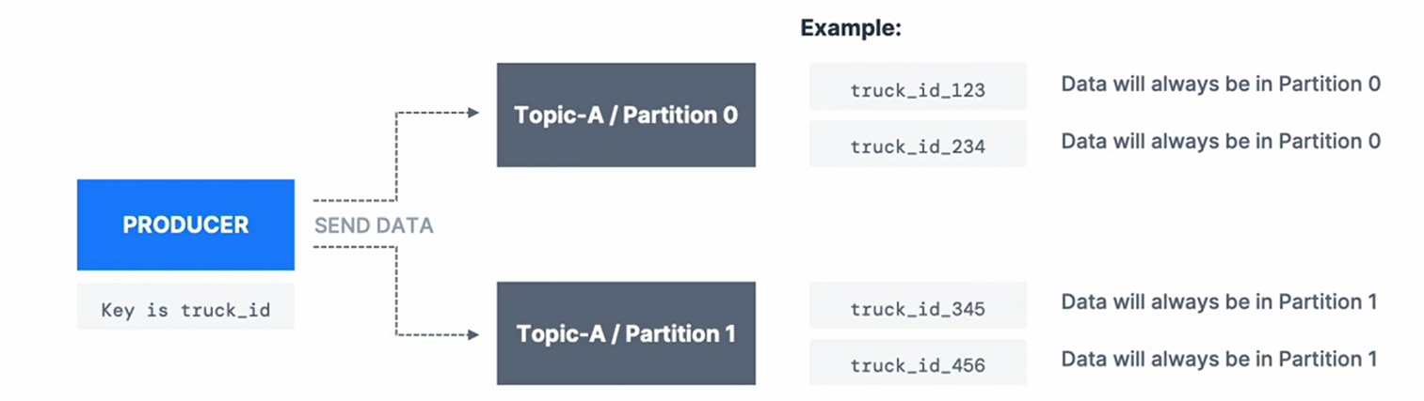

**Kafka Message Anatomy:**

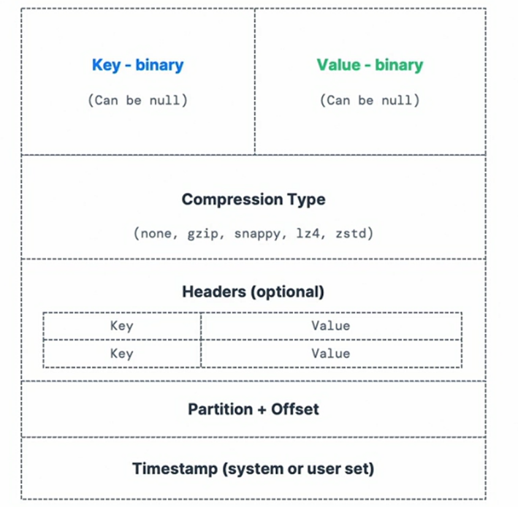

**Key Hashing:**

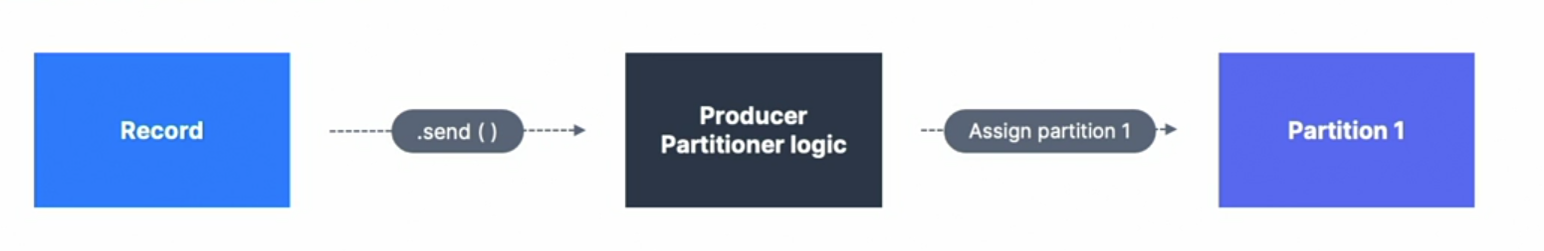



**Consumers:**

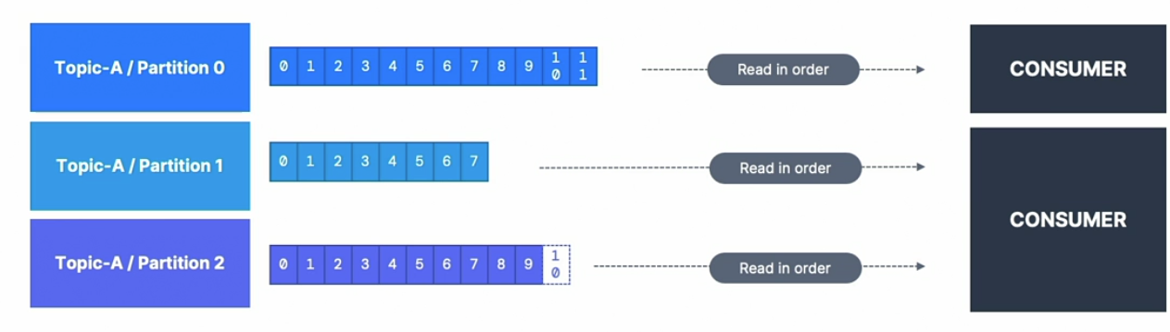

**Consumer Groups:**

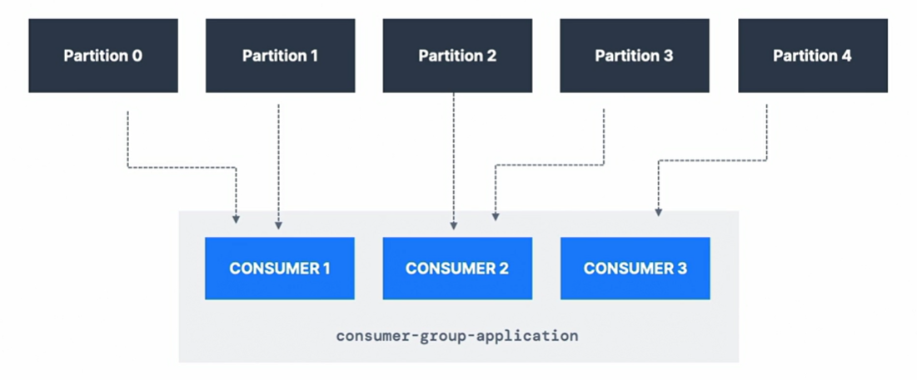

**Too Many Consumers:**

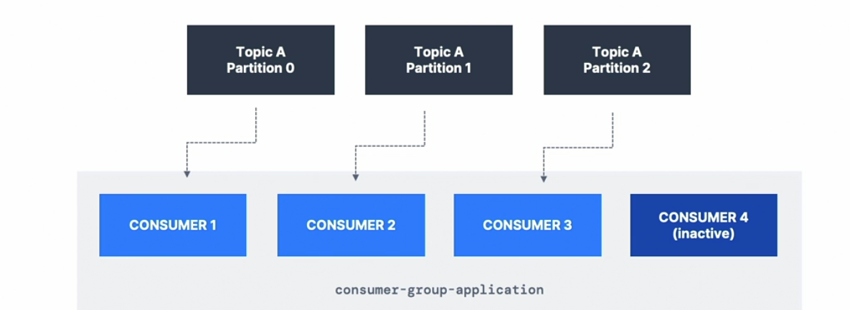

**Multiple Consumers on One topic:**

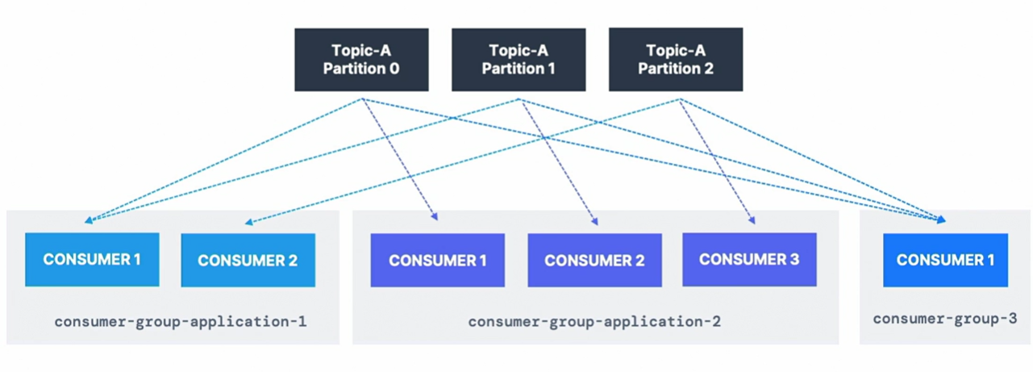

**Consumer offsets:**

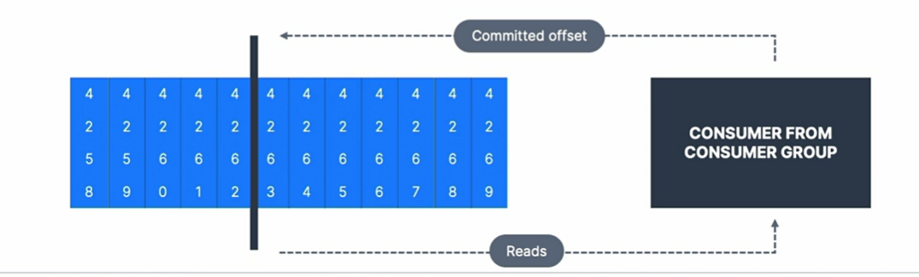

**Kafka Brokers**



**Horizontal scaling:**

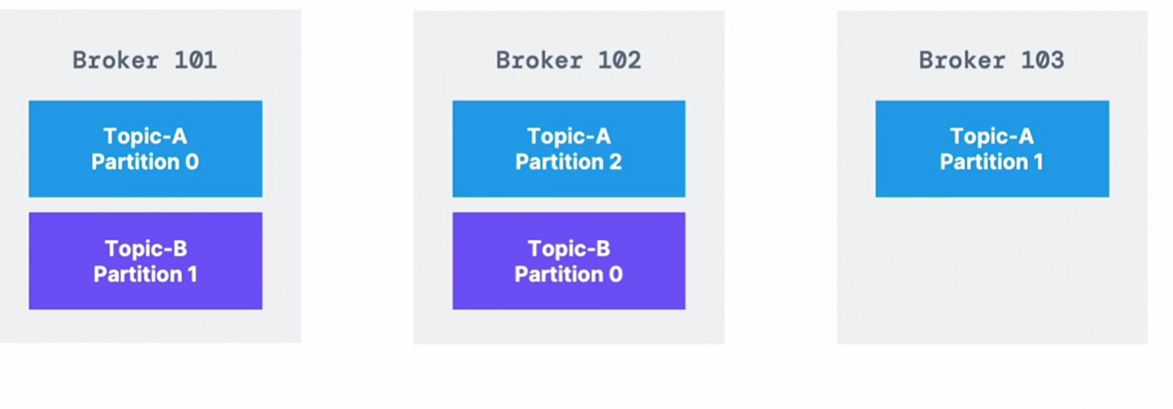

**Kafka Broker discovery:**

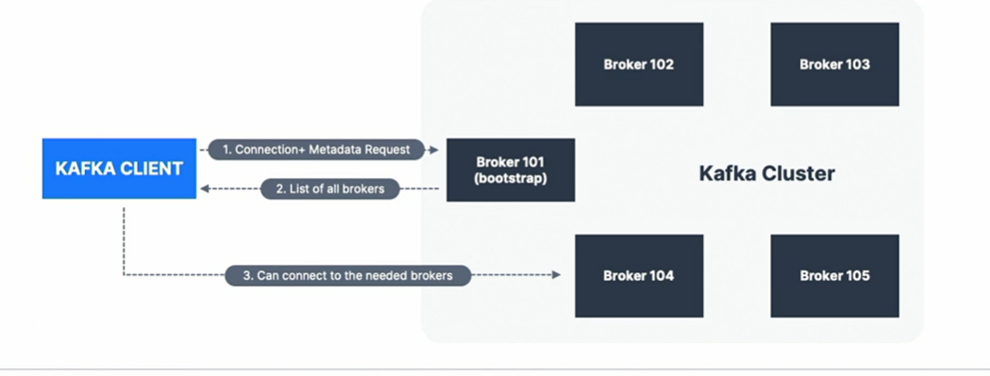

**Replication Factor:**

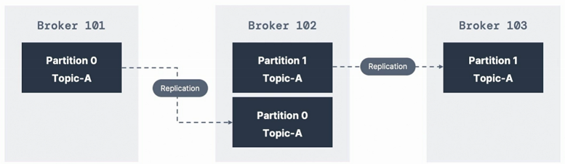

**Producer acknowledgement:**

